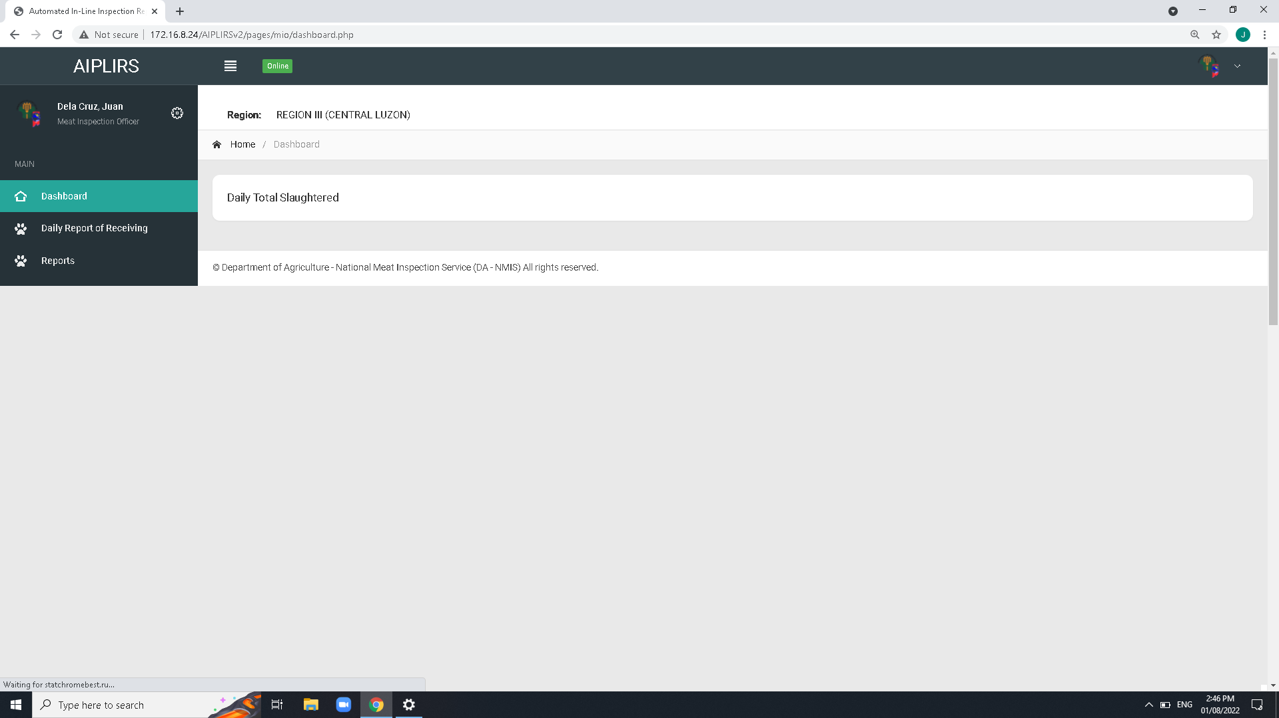

Create a summary card for the receiving, fit for slaughter, fit for human consumption

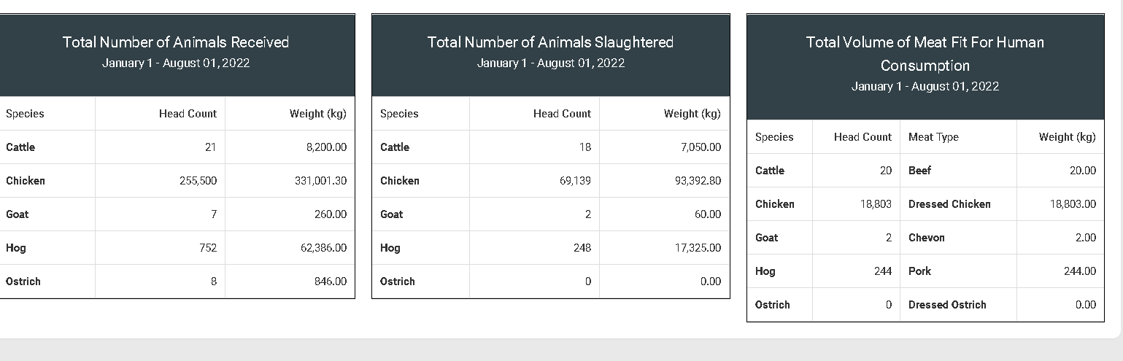

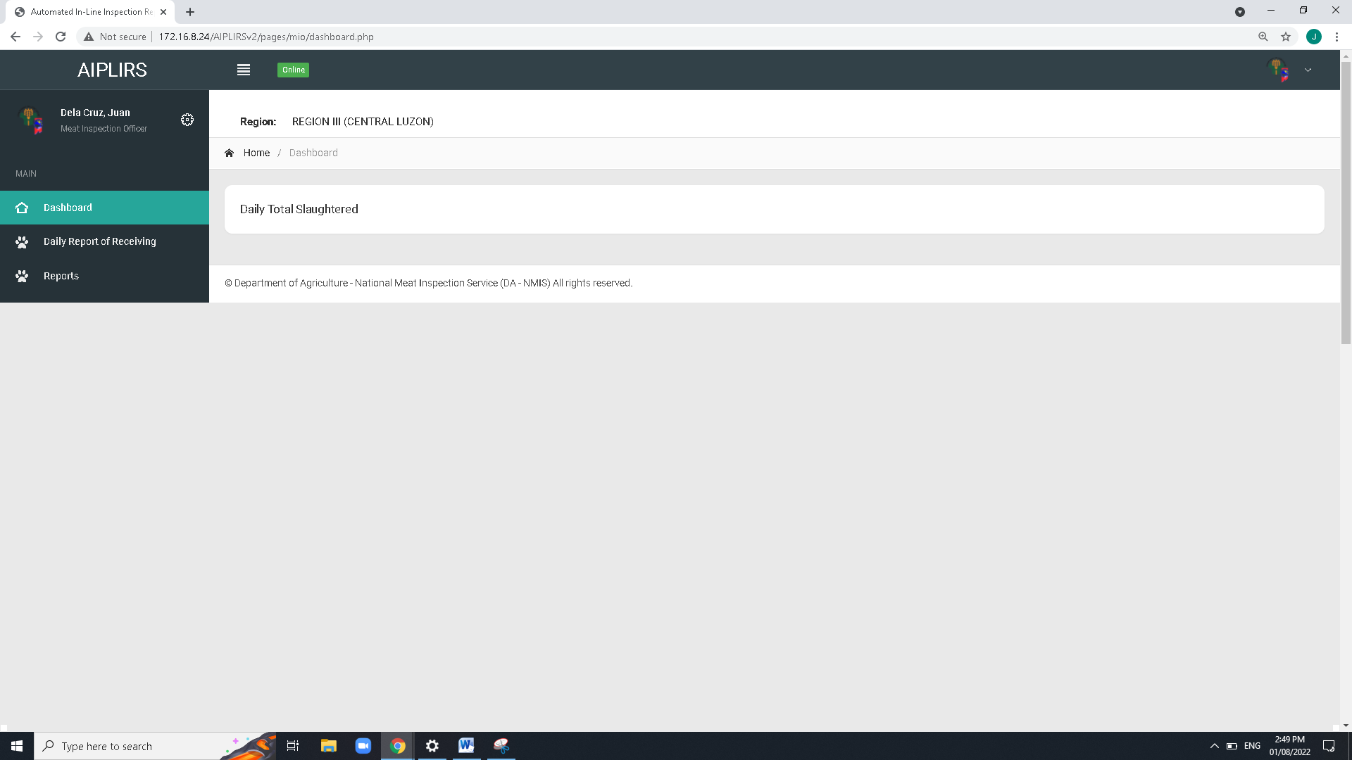

Remove Navigation bar header and breadcrumbs on all pages

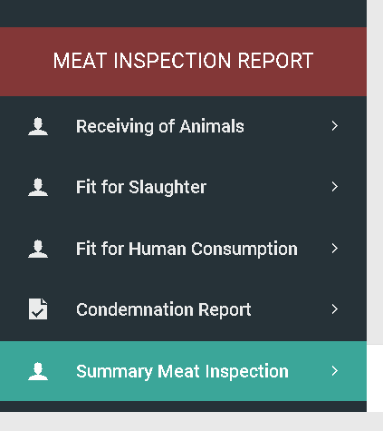

To be added on MIO account sidebar:

Output is the summary on the all Meat establishment assignment base on dates

(suggestions: tick boxes for the Current, previous)

Make column sticky css from “date and time to species”

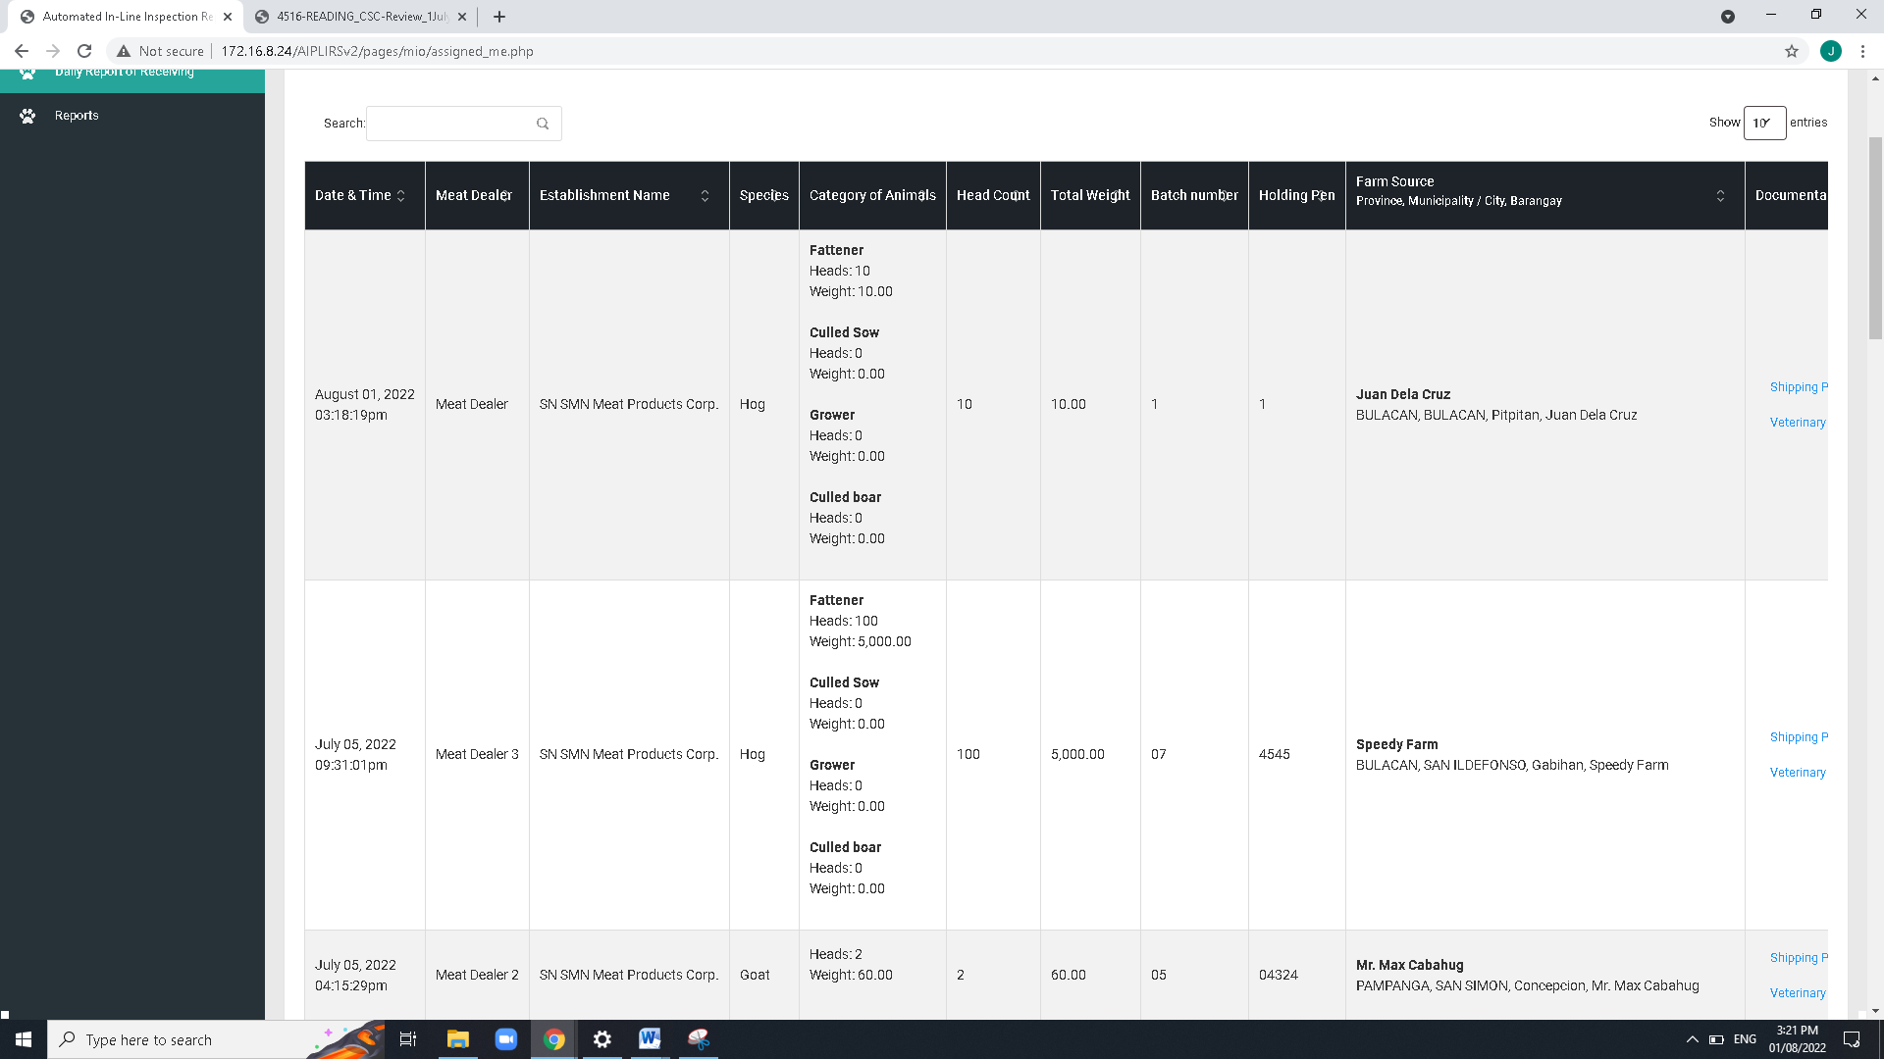

Change header title

Establishment to Meat establishment

Total weight to total weight(kg)

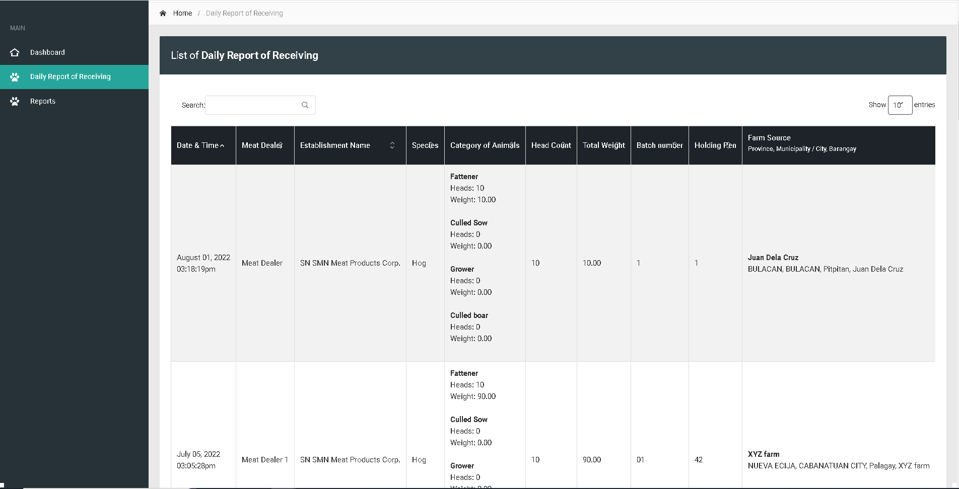

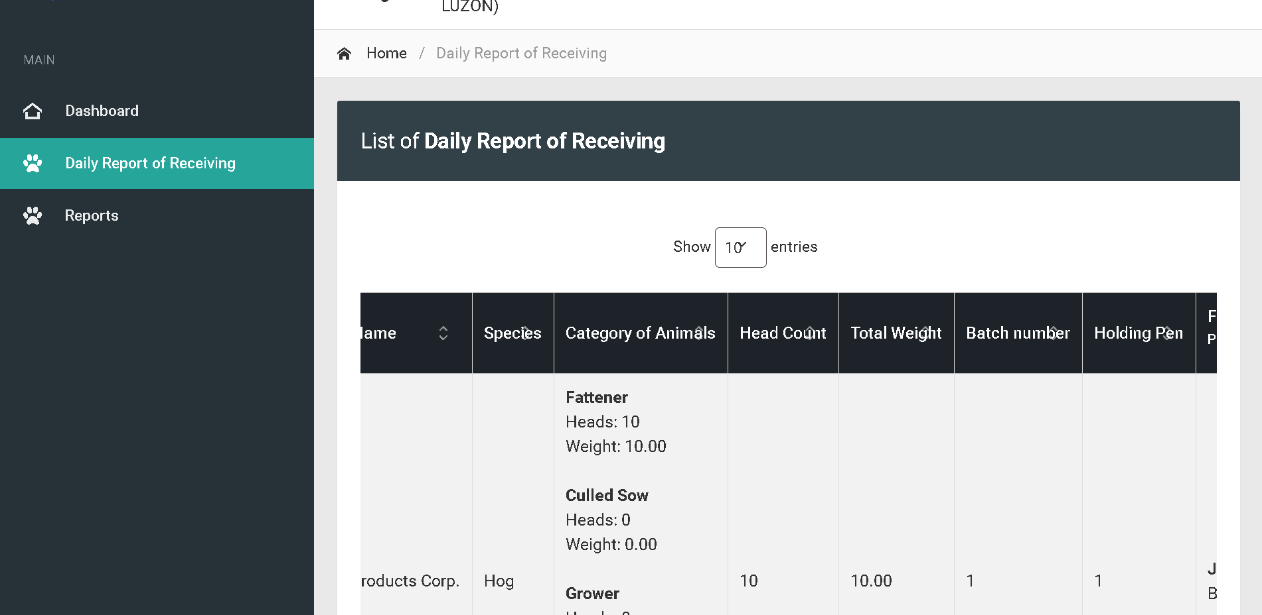

Bactch and holding pen : Text align center

For the column of head count and total weight make it text right

Change sidebar title to Daily Receiving of Animals

Change title to Daily Receiving of Animals

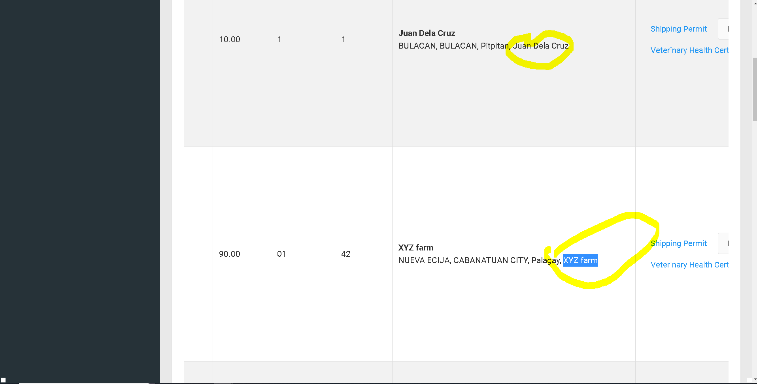

Remove on fetch data of line code

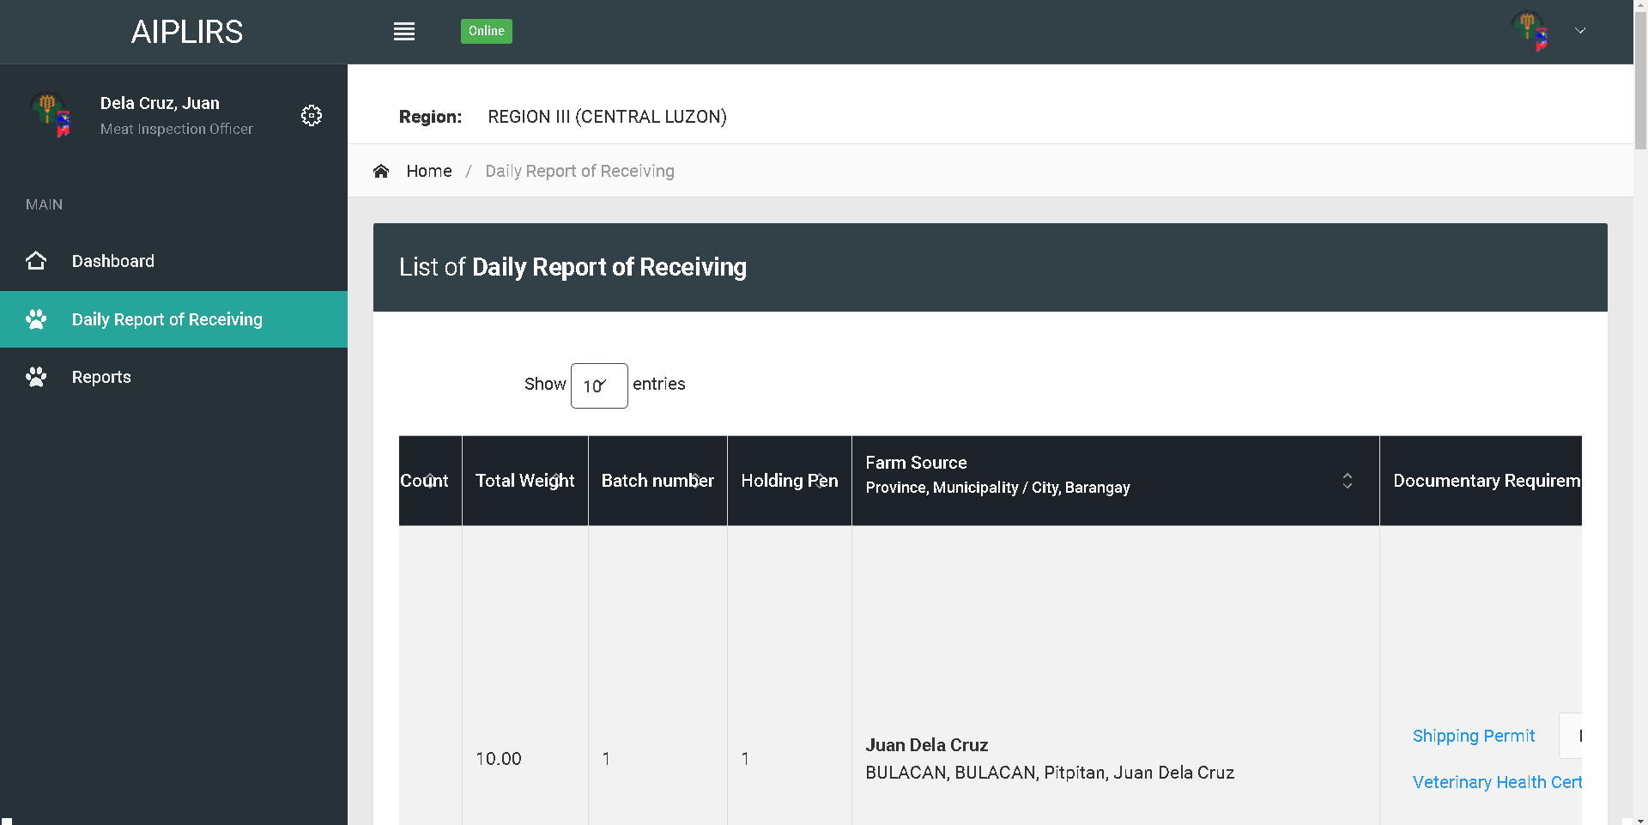

Change table header

Farm Source and Address

Remove indicator

Change address format to “barangay, city, province”

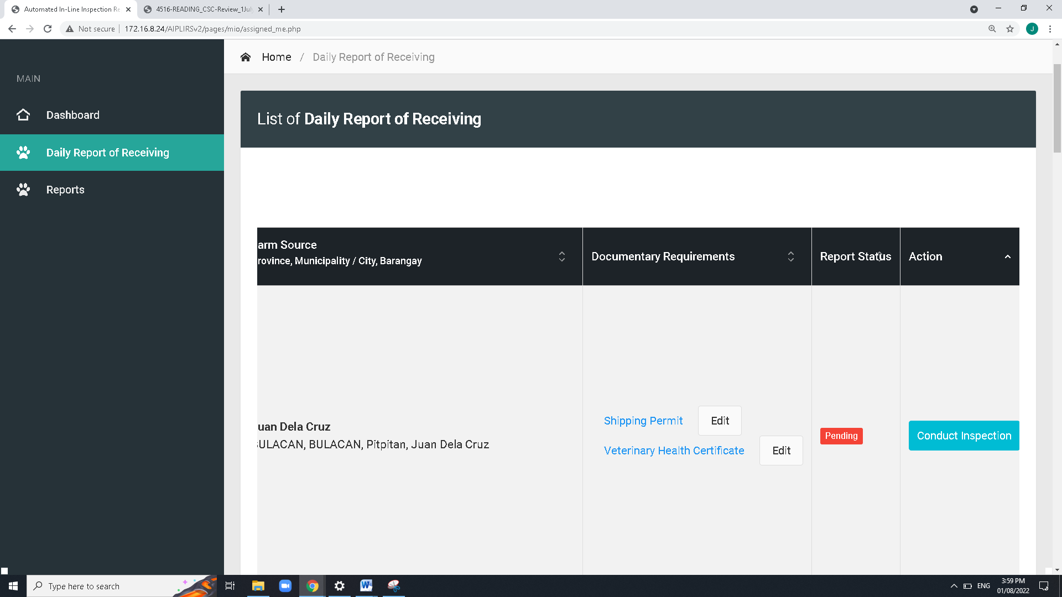

Add approve for the “Request to edit ” in the MIO button actions

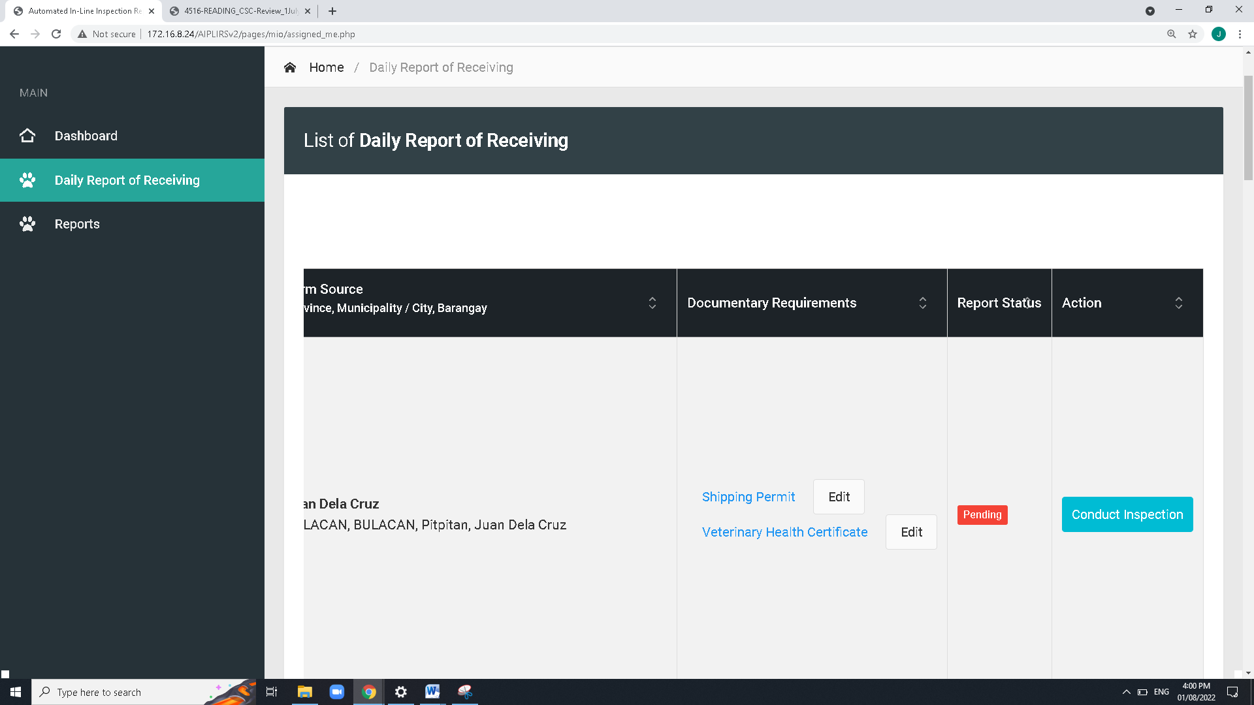

ME: Upload or Captured

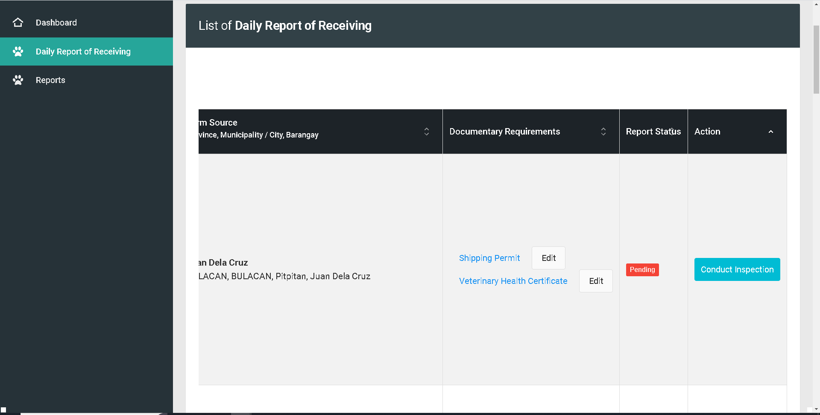

For the button of the of the shipping permit should change to Accept / Reject. Then system will notifiy the meat establishment for the edit of document

Change edit Accept / Reject

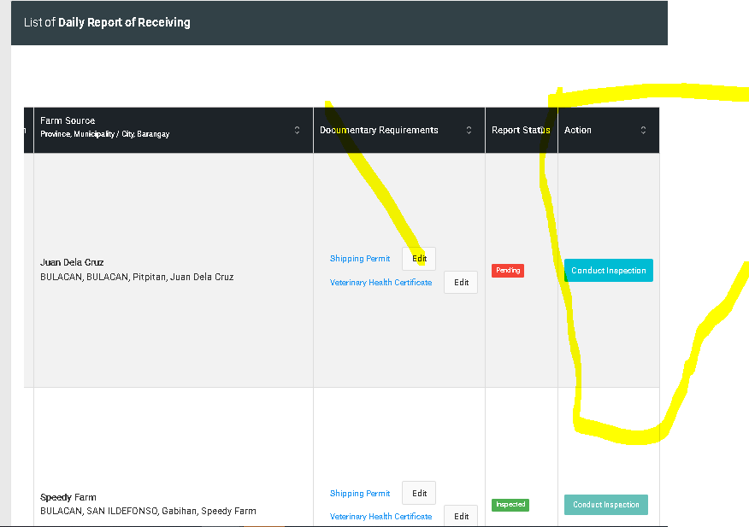

On action button change conduct inspection to proceed and button for reject

**Request to edit DRR** button:

for the reject button after clicking modal will appear and MIO will note the deficiencies or the correction of the data specially documentary req.

notification will appear on ME dashboard for the remarks,

**conduct inspection button** changes to proceed to inspection.

remove edit button on documentary requirements

report status:

add another page for the viewing of data and take actions, table data remove the drr status

Status: Pending

DASHBOARD CARDS : Status, Pending, Ongoing, completed

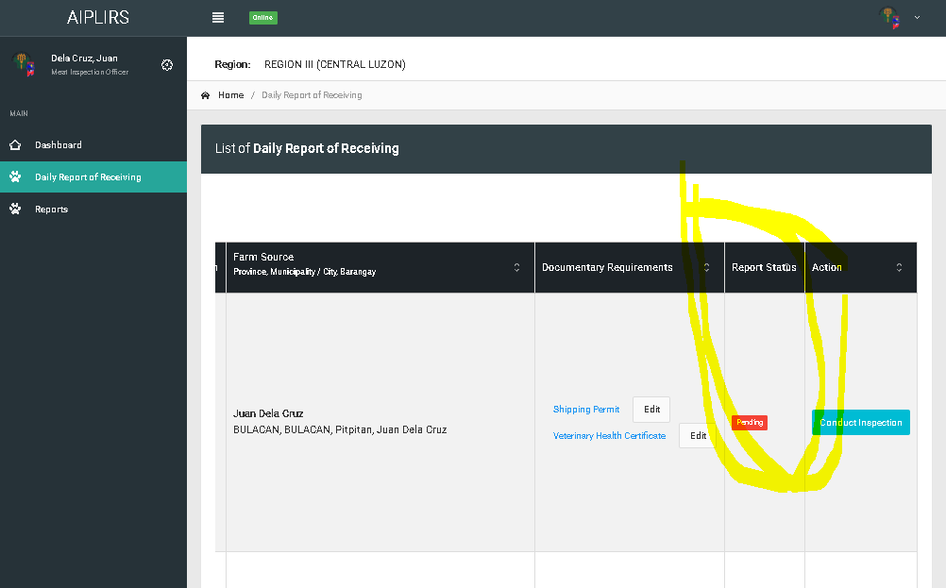

Remove the header highlighted

Details of DRR page: details

‘remarks must be visible both MIO and ME

Add a column for the “DRR status” and “Inspection report status”

Report status change to “DRR Status”

**DRR status**: **pending** (request to edit), **Completed**,

**Details of DRR page action**: **proceed to inspection**(DRR status will update to approved), **request to edit**

**Inspection report status**: **Pending**(upon checking Drr page), **On-going**(if DRR is approved color: orange), completed(Antemortem & postmortem conducted)

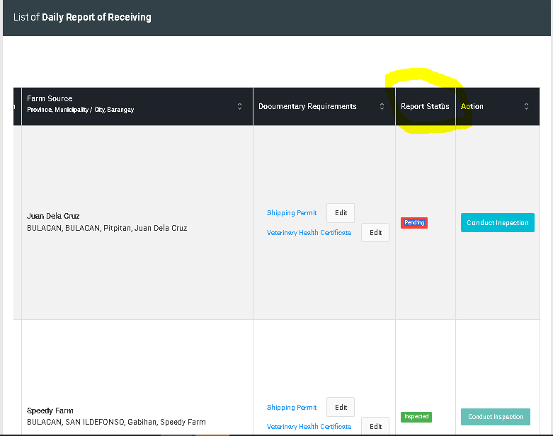

Change header for the DRR status

DRR status